MASTER REPORT: Medical Patterns and Trends

Mohajit Banik

Data Analysis with Python

National Institute of Industrial Training

Ishapore, West Bengal

mohajit25@gmail.comArpita Goswami

Data Analysis with Python

National Institute of Industrial Training

Barrackpore, West Bengal

goswamiarpita872@gmail.com

*Abstract*—This study investigates the trends and patterns in AIDS-related deaths across various states from the year 2000 to 2014, using the AIDS dataset. The primary objective is to identify significant patterns and correlations that can inform public health strategies and interventions. The dataset includes demographic information, state-wise distribution, age groups, and the timeline of deaths.

Advanced data processing techniques, including data cleaning, exploratory data analysis (EDA), and machine learning algorithms, are employed to ensure the accuracy and depth of the findings. Preliminary results indicate that factors such as age, state of residence, and access to healthcare services significantly influence AIDS-related mortality. For instance, states with better healthcare infrastructure and higher awareness levels exhibit lower mortality rates.

The study underscores the importance of targeted public health interventions and policies tailored to the unique challenges of different states. By providing a detailed analysis of the most recent data, this research offers valuable insights into the current state of AIDS mortality. The findings highlight the need for comprehensive healthcare support systems and proactive measures to address the challenges faced by individuals living with AIDS.

This research contributes to the broader understanding of AIDS and supports the development of effective strategies to reduce AIDS-related deaths. The insights gained from this study will be instrumental for healthcare providers, policymakers, and public health professionals in creating a healthier and more supportive environment for individuals affected by AIDS.

Introduction

The healthcare sector is increasingly leveraging data-driven insights to enhance patient care and operational efficiency. This Master Report consolidates detailed analyses of five diverse medical datasets, each providing unique perspectives on significant health challenges and trends. By integrating findings from various domains, we aim to demonstrate the breadth and depth of data analytics' impact on healthcare, offering a comprehensive overview of how different facets of medical data can drive better outcomes. Our goal is to showcase how meticulous data analysis can uncover valuable patterns and correlations, ultimately informing better decision-making, optimizing resource utilization, and improving overall healthcare delivery. Through this report, we highlight the transformative potential of data analytics in addressing critical issues in the healthcare industry and advancing patient care.

Firstly, we examined a comprehensive dataset of hospital data. This dataset encompasses a wide range of information, including patient demographics, medical records, treatment details, and hospital operations. By analyzing this data, we aimed to uncover patterns and trends that could inform better decision-making and improve healthcare outcomes. Our exploration included various aspects such as disease prevalence, treatment outcomes, resource utilization, and operational efficiency. By understanding these elements, we sought to provide valuable insights into the hospital’s performance and highlight areas for improvement. This study underscores the importance of leveraging historical data to drive future strategies and optimize healthcare delivery.

Secondly, we delved into a dataset of pregnancy demographics collected focusing on factors influencing maternal and neonatal health outcomes. This dataset includes a wide range of demographic variables such as age, ethnicity, socioeconomic status, and health indicators of pregnant individuals. By examining these variables, we aimed to identify significant trends, patterns, and disparities that could inform healthcare policies and practices to enhance maternal and neonatal health. Demographic characteristics like age, ethnicity, and socioeconomic status play a pivotal role in determining pregnancy outcomes. For instance, younger and older age groups often face higher risks of complications, while individuals from lower socioeconomic backgrounds may encounter challenges in accessing quality prenatal care. Additionally, ethnic disparities in birth outcomes highlight the need for targeted interventions to address the specific needs of diverse populations.

Thirdly, we analyzed a dataset of mental health indicators during the COVID-19 quarantine, examining the impact of quarantine measures on mental health. This dataset includes demographic variables, mental health metrics, and quarantine-related factors, providing a holistic view of the pandemic’s impact. Quarantine has disrupted routines, social interactions, and economic stability, leading to increased stress, anxiety, and depression. Key factors such as age, socioeconomic status, and pre-existing mental health conditions influence these outcomes, with younger individuals and those from lower socioeconomic backgrounds being especially vulnerable. By leveraging advanced data analysis techniques, we aimed to identify significant correlations and insights that could inform mental health interventions and policies.

Fourthly, we explored mental health trends among tech professionals in the post-pandemic era, focusing on the challenges introduced by remote and hybrid work environments. This dataset provides a comprehensive overview of mental health trends among tech professionals, including demographic information, job roles, work environments, mental health conditions, and access to mental health resources. The tech industry is known for its high-pressure environment, long working hours, and constant need for innovation, all of which can contribute to mental health issues such as anxiety, depression, and burnout. By analyzing these variables, we aimed to uncover patterns and correlations that could inform better mental health support strategies within the tech industry. Our analysis leverages advanced data processing techniques, including data cleaning, exploratory data analysis (EDA), and machine learning algorithms, to ensure robust and insightful findings.

Finally, we analyzed a dataset of AIDS-related deaths highlighting the ongoing efforts and challenges in combating the AIDS epidemic. This dataset provides a comprehensive overview of AIDS-related deaths across various states, capturing the latest trends and patterns in AIDS mortality. It encompasses a wide range of variables, including demographic information, state-wise distribution, age groups, and the timeline of deaths. By examining these variables, we aimed to uncover patterns that could inform public health strategies and interventions to reduce AIDS-related mortality. Despite advancements in medical treatments and preventive measures, AIDS remains a critical issue. Understanding the prevalence and factors associated with AIDS-related deaths is crucial for developing effective interventions and policies.

Through these comprehensive analyses, this Master Report underscores the transformative potential of data analytics in addressing diverse healthcare challenges. By meticulously cleaning, processing, and analyzing various medical datasets, we provide actionable insights that can inform healthcare strategies and policies. Ultimately, this report demonstrates the vital role of data analytics in improving patient care, optimizing healthcare delivery, and addressing public health challenges, contributing to more effective and efficient healthcare systems.

## **Data Cleaning**

Data cleaning is a pivotal step in data preprocessing, essential for transforming raw data into a polished, analysis-ready dataset. In this project, we meticulously re-entered integer values with their correct legends, replacing irrelevant entries with precise, meaningful data. This diligent process ensured that each element was accurately represented, enhancing the relevance and accuracy of our dataset. By aligning data with its correct legends, we’ve not only refined the dataset but also optimized it for insightful analysis and impactful visualization. This attention to detail lays a strong foundation for robust, data-driven decision-making and ensures that our results are both reliable and actionable.

**The cleaning: -**

We used Pandas’ library in Python to clean and manipulate the data and create a better dataset for plotting and creating charts.

ad=ad.drop(["Indicator", "Race", "Sex", "Age group", "Misc"], axis=1)

ad.head()

The powerful `drop()` function was skillfully utilized to eliminate irrelevant columns containing single duplicated values, streamlining the dataset. Subsequently, the `head()` function was called to verify the effectiveness of this operation. This crucial step confirmed that the data preprocessing was on track, ensuring the dataset retained only meaningful and diverse information. By meticulously cleaning and verifying the data, we set the stage for more accurate and insightful analysis, optimizing the dataset for further exploration.

ad['Cases'] = ad['Cases'].str.replace(',', '').astype(int)

ad['Population'] = ad['Population'].str.replace(',', '').astype(int)

In this code snippet, we effectively employed the `str.replace` function to remove commas from elements in specific columns, followed by the `astype` function to convert these columns, namely Cases and Population, into integers. This crucial transformation enhanced the dataset's integrity, paving the way for more accurate insights and better visualizations. By meticulously cleaning and converting the data, we ensured a robust foundation for subsequent analysis and meaningful data exploration.

## **Data Visualizations**

Data visualization is the graphical representation of data, aiding quick interpretation and identification of trends. It encompasses various techniques like bar charts, histograms, and scatter plots to enhance communication and facilitate informed decision-making. Ultimately, it makes complex data accessible, understandable, and actionable, benefiting both technical and non-technical users.

* 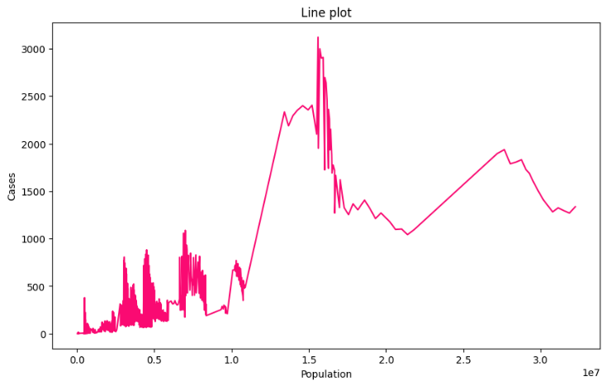**Population vs. Cases: A Dynamic Overview**

This line plot graph visualizes the relationship between population size and the number of cases. The x-axis represents the population, ranging from 0 to 3.0, while the y-axis shows the number of cases, ranging from 0 to 3000. The line plot highlights fluctuations in case numbers across different population sizes, with notable peaks and troughs indicating variations in case distribution.

**Key observations-**

1. **Axes:**
   * X-axis: Represents population size, ranging from 0 to approximately 30 million.
   * Y-axis: Represents the number of cases, ranging from 0 to over 3000.
2. **Data Trends:**
   * The line shows fluctuations in the number of cases as the population size increases.
   * There are notable peaks in the number of cases, particularly around a population size of 1.5 million, suggesting a correlation between population density and the number of cases.
3. **Fluctuations:**
   * The plot shows significant variability in case numbers, with sharp increases and decreases, indicating potential outbreaks or changes in reporting practices.
4. **Interpretation:**
   * The spikes in cases may suggest periods of increased transmission or reporting, possibly linked to public health interventions, seasonal factors, or changes in population behaviour.
   * The overall trend may indicate that as the population increases, the number of cases also tends to rise, reflecting the impact of population density on disease spread.

**Conclusion:**

Overall, the line plot effectively visualizes the relationship between population size and the number of cases, highlighting significant trends and fluctuations. Further analysis could explore the factors influencing these patterns, such as public health measures, demographic changes, and environmental factors. The graph reveals significant variability in case numbers across different population sizes, suggesting the presence of clusters or hotspots where cases are particularly high or low. This variability indicates that certain population sizes may be more susceptible to higher case numbers, which could be influenced by various factors such as population density, healthcare access, or regional policies. Further investigation into these factors could provide valuable insights for targeted interventions and resource allocation.

* 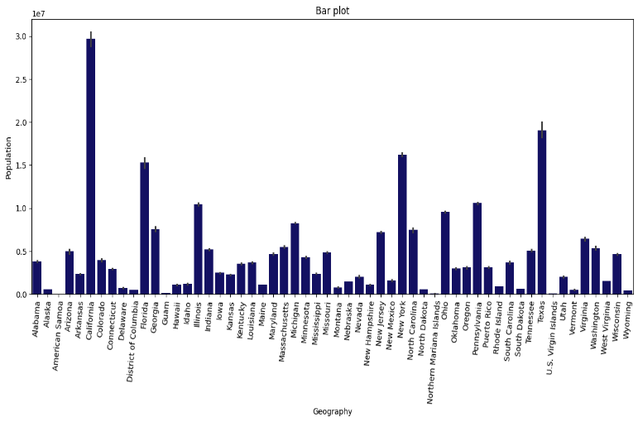

Bottom of Form

* **Global Population Distribution by Geography**

This bar graph provides a comparative visualization of population sizes across various countries and territories. Each bar represents the population of a specific geography, with the height of the bar corresponding to the population size in tens of millions. The graph highlights the demographic distribution, allowing for easy comparison of population sizes among different regions. By this, one can quickly identify which countries or territories have larger or smaller populations. This visual representation is useful for understanding global population trends and disparities, and it can serve as a basis for further analysis of the factors influencing population growth and distribution.

**Key observations-**

1. **Axes:**
   * X-axis: Represents different states and territories, including Alabama, Alaska, California, Florida, and others.
   * Y-axis: Represents the population, with values ranging from 0 to approximately 30 million.
2. **Bars:**
   * Each bar represents the population of a specific state or territory. The height of the bar indicates the population size, with California showing the highest population, followed by Texas and Florida.
   * The error bars indicate variability or uncertainty in the population estimates, suggesting that the data may have some degree of error or confidence intervals.
3. **Observations:**
   * California has the highest population, significantly larger than other states, indicating its status as a major population center.
   * States like Texas and Florida also show substantial populations, reflecting their large urban areas and economic opportunities.
   * Many states have relatively low populations, particularly in the northern and rural areas, which may indicate lower population density or less urbanization.
4. **Implications:**
   * Understanding population distribution is crucial for resource allocation, policy-making, and planning in areas such as healthcare, education, and infrastructure.
   * States with larger populations may require more resources and services, while those with smaller populations might focus on different priorities.

**Conclusion:**

Overall, the bar plot effectively visualizes the population distribution across various states and territories, highlighting significant trends and areas of concentration. Further analysis could explore the factors influencing these population sizes, such as economic conditions, migration patterns, and demographic trends. The graph highlights significant disparities in population sizes among different geographies. Some regions have notably larger populations, which may reflect underlying economic, social, or political factors influencing population distribution.

* 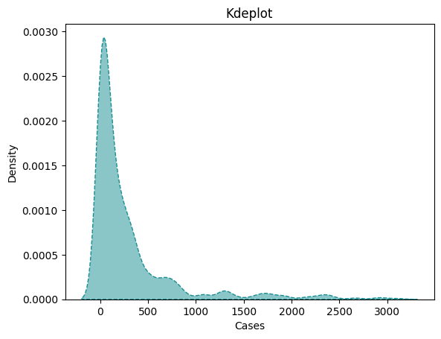**Skewed Distribution of Case Density**

This graph represents a kernel density estimate (KDE) of the variable ‘Cases’. The KDE plot visualizes the probability density function, showing how frequently different ranges of case numbers occur within the dataset. The peak of the distribution is concentrated around lower-case numbers, with a long tail extending towards higher case numbers, indicating a skewed distribution. This suggests that the majority of the cases are clustered at the lower end, with fewer occurrences as the case numbers increase. The long tail signifies the presence of outliers or rare events with higher case numbers. This type of distribution is common in datasets where extreme values are less frequent but still significant. The KDE plot provides a smooth, continuous estimate of the data’s density, making it easier to observe the overall pattern and trends within the dataset. This visualization is particularly useful for identifying the central tendency and spread of the data, as well as for detecting any anomalies or unusual patterns.

**Key observations-**

1. **Axes:**
   * X-axis: Represents the frequency of work interference, categorized into "Often," "Never," "Rarely," and "Sometimes."
   * Y-axis: Represents the count of individuals, indicating how many responses fall into each category of work interference.
2. **Bars:**
   * The bars are color-coded to represent self-employment status:

* Green Bars: Indicate individuals who are self-employed (Yes).
* Red Bars: Indicate individuals who are not self-employed (No).
  + Each work interference category has two bars: one for each self-employment status.

1. **Data Interpretation:**
   * The "Sometimes" category shows the highest count of individuals, particularly among those who are not self-employed, indicating that work interference is a significant issue for this group.
   * The "Never" category has the lowest counts for both self-employed and non-self-employed individuals, suggesting that very few people report no work interference.
2. **Trends:**
   * There is a noticeable trend where non-self-employed individuals report higher counts of work interference, especially in the "Sometimes" and "Never" categories.
   * Self-employed individuals show a more balanced distribution across the categories, but still have fewer counts in the "Often" category compared to non-self-employed individuals.
3. **Clinical Relevance:**
   * Understanding the relationship between work interference and self-employment can provide insights into how work conditions affect mental health and productivity.
   * This information could be valuable for employers and policymakers in creating supportive work environments.

**Conclusion:**

The KDE plot reveals that the majority of cases are clustered within a lower range, with significantly fewer cases as the numbers increase. This skewed distribution suggests that lower case counts are more common, potentially highlighting rare events or specific thresholds in the data-generating process.

* 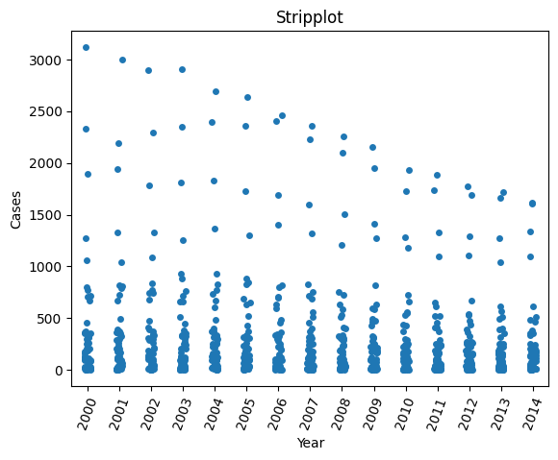**Yearly Case Distribution from 2000 to 2014**

This strip plot graph displays the distribution of individual case counts for each year from 2000 to 2014. Each dot represents a specific case count for a given year, allowing for a clear visualization of how cases are dispersed annually over these fifteen years. The graph effectively highlights the spread and density of cases for each year, making it easy to observe any patterns or anomalies. By examining the distribution of dots, one can identify years with higher or lower concentrations of cases. This visualization is particularly useful for detecting trends, outliers, and variations in case counts over time. It provides a comprehensive overview of the annual case distribution, facilitating a better understanding of the data’s temporal dynamics.

**Key observations-**

1. **Axes:**
   * X-axis: Represents the years, ranging from 2000 to 2014.
   * Y-axis: Represents the number of cases, ranging from 0 to 3,000.
2. **Data Points:**
   * Each dot represents the number of cases reported in a given year. The distribution of dots indicates the frequency of cases over the years.
   * The density of points in the earlier years (2000-2005) suggests a higher number of cases, while there is a noticeable decline in cases as the years progress.
3. **Trends:**
   * There is a clear downward trend in the number of cases from around 2005 onwards, indicating a potential improvement in the situation being measured (e.g., a disease outbreak, health issue, etc.).
   * The clustering of points at lower counts in the later years suggests that fewer cases are being reported, which could indicate successful interventions or changes in reporting practices.
4. **Implications:**
   * The decline in cases over the years may reflect effective public health measures, increased awareness, or changes in population behaviour.
   * Further analysis could explore the factors contributing to this decline, such as vaccination rates, health policies, or socioeconomic changes.

**Conclusion:**

Overall, the strip plot effectively visualizes the trend of cases over the years, highlighting a significant decrease in reported cases from 2000 to 2014. Further investigation into the underlying causes of this trend would be beneficial for understanding the dynamics at play. The strip plot reveals a consistent pattern of case occurrences across the years, with no significant upward or downward trends. This suggests that the number of cases has remained relatively stable over the observed period, indicating steady conditions related to the data being represented.

* 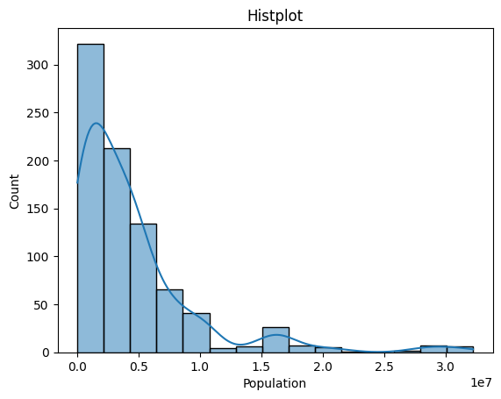**Age Population Distribution Across Sampled Regions**

This histogram represents the frequency distribution of population sizes across various sampled regions. The x-axis shows the population size, while the y-axis indicates the count of regions falling into each population category. The overlaid line graph follows the general shape of the histogram, providing a smooth estimate of the distribution. The histogram’s bars indicate how many regions fall within specific population ranges, with the highest bar showing the most common population size. The line graph helps to visualize the overall trend and density of the population distribution. This combined visualization allows for a clear understanding of how population sizes are spread across the sampled regions, highlighting the prevalence of smaller populations and the gradual decrease in frequency as population size increases. This insight can be useful for demographic analysis and identifying patterns in population distribution.

**Key observations-**

1. **Axes:**
   * X-axis: Represents population size, ranging from 0 to approximately 30 million.
   * Y-axis: Represents the count of occurrences for each population range.
2. **Histogram:**
   * The bars represent the frequency of regions or entities within specific population ranges. The tallest bar indicates that a significant number of regions have a population close to zero, suggesting many small or less populated areas.
3. **Kernel Density Estimate (KDE):**
   * The blue line overlaid on the histogram represents the KDE, which provides a smoothed estimate of the population distribution. It shows that while many regions have small populations, there are fewer regions with larger populations, indicating a right-skewed distribution.
4. **Distribution Shape:**
   * The distribution appears to be positively skewed, with a long tail extending towards higher population sizes. This suggests that while most regions have smaller populations, a few regions have significantly larger populations.

**Conclusion:**

Overall, the histplot effectively visualizes the population distribution, highlighting the concentration of smaller populations and the presence of a few larger populations. This information can be useful for understanding demographic trends and planning resources accordingly. The histogram reveals that the majority of sampled regions have relatively small population sizes, with a significant drop in frequency as population size increases. This indicates that smaller populations are more common in this dataset, highlighting a skewed distribution towards lower population sizes.

**OVERALL CONCLUSION**

The analysis of the AIDS dataset from the years 2000 to 2014 provides a comprehensive overview of AIDS-related mortality trends across various states. The findings reveal significant patterns and correlations that underscore the importance of targeted public health interventions and support systems. Factors such as age, state of residence, and access to healthcare services play a crucial role in influencing AIDS-related mortality.

The study highlights that states with better healthcare infrastructure and higher awareness levels exhibit lower mortality rates. These insights emphasize the need for policymakers to prioritize healthcare support and create a public health environment that promotes awareness and accessibility. Implementing proactive measures, such as improving healthcare infrastructure, increasing awareness campaigns, and providing better access to treatment, can significantly reduce AIDS-related deaths.

Furthermore, the analysis underscores the importance of continuous monitoring and assessment of AIDS mortality trends. By leveraging advanced data processing techniques and machine learning algorithms, this study provides a robust framework for understanding and addressing the challenges associated with AIDS. The findings serve as a valuable resource for healthcare providers, policymakers, and public health professionals in developing effective strategies to support individuals living with AIDS.

In conclusion, this study contributes to the ongoing discourse on AIDS and offers actionable insights for reducing AIDS-related deaths. By addressing the unique challenges of different states, we can create a healthier and more supportive environment for individuals affected by AIDS. The insights gained from this research will be instrumental in shaping future public health initiatives and policies aimed at combating AIDS.